# Access control vulnerabilities and privilege escalation

In this section, we describe:

* Privilege escalation.
* The types of vulnerabilities that can arise with access control.
* How to prevent access control vulnerabilities.

# What is access control?

Access control is the application of constraints on who or what is authorized to perform actions or access resources. In the context of web applications, access control is dependent on authentication and session management:

* **Authentication** confirms that the user is who they say they are.
* **Session management** identifies which subsequent HTTP requests are being made by that same user.
* **Access control** determines whether the user is allowed to carry out the action that they are attempting to perform.

Broken access controls are common and often present a critical security vulnerability. Design and management of access controls is a complex and dynamic problem that applies business, organizational, and legal constraints to a technical implementation. Access control design decisions have to be made by humans so the potential for errors is high.

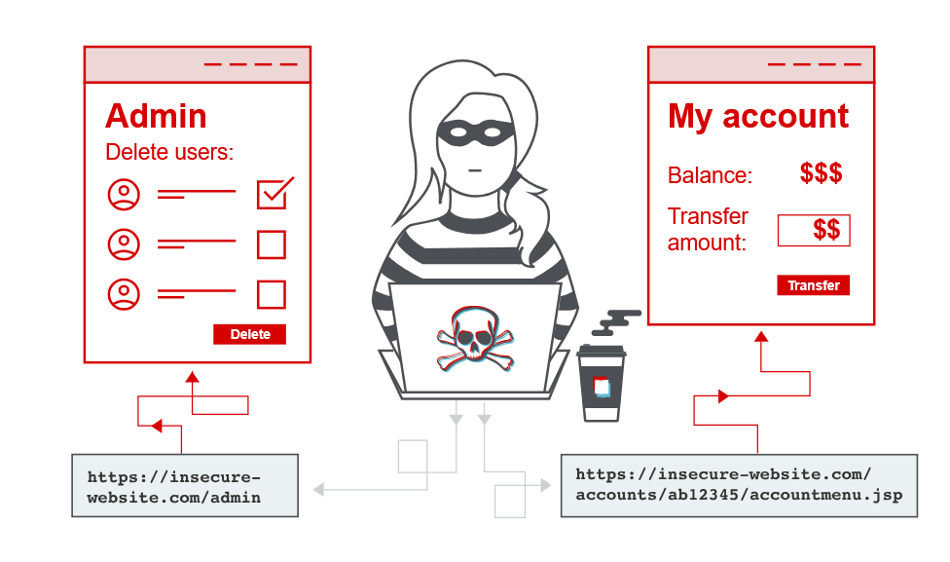

**Read more**

* [Access control security models](https://portswigger.net/web-security/access-control/security-models)

### Vertical access controls

Vertical access controls are mechanisms that restrict access to sensitive functionality to specific types of users.

With vertical access controls, different types of users have access to different application functions. For example, an administrator might be able to modify or delete any user's account, while an ordinary user has no access to these actions. Vertical access controls can be more fine-grained implementations of security models designed to enforce business policies such as separation of duties and least privilege.

### Horizontal access controls

Horizontal access controls are mechanisms that restrict access to resources to specific users.

With horizontal access controls, different users have access to a subset of resources of the same type. For example, a banking application will allow a user to view transactions and make payments from their own accounts, but not the accounts of any other user.

### Context-dependent access controls

Context-dependent access controls restrict access to functionality and resources based upon the state of the application or the user's interaction with it.

Context-dependent access controls prevent a user performing actions in the wrong order. For example, a retail website might prevent users from modifying the contents of their shopping cart after they have made payment.

# Examples of broken access controls

Broken access control vulnerabilities exist when a user can access resources or perform actions that they are not supposed to be able to.

### Vertical privilege escalation

If a user can gain access to functionality that they are not permitted to access then this is vertical privilege escalation. For example, if a non-administrative user can gain access to an admin page where they can delete user accounts, then this is vertical privilege escalation.

#### Unprotected functionality

At its most basic, vertical privilege escalation arises where an application does not enforce any protection for sensitive functionality. For example, administrative functions might be linked from an administrator's welcome page but not from a user's welcome page. However, a user might be able to access the administrative functions by browsing to the relevant admin URL.

For example, a website might host sensitive functionality at the following URL:

<https://insecure-website.com/admin>

This might be accessible by any user, not only administrative users who have a link to the functionality in their user interface. In some cases, the administrative URL might be disclosed in other locations, such as the robots.txt file:

<https://insecure-website.com/robots.txt>

Even if the URL isn't disclosed anywhere, an attacker may be able to use a wordlist to brute-force the location of the sensitive functionality

LAB

APPRENTICE [Unprotected admin functionality](https://portswigger.net/web-security/access-control/lab-unprotected-admin-functionality)   
Sol- go to /robots.txt 🡪 found /administrator-panel now delete carlos….. in real world we can brute force these parameters.

In some cases, sensitive functionality is concealed by giving it a less predictable URL. This is an example of so-called "security by obscurity". However, hiding sensitive functionality does not provide effective access control because users might discover the obfuscated URL in a number of ways.

Imagine an application that hosts administrative functions at the following URL:

<https://insecure-website.com/administrator-panel-yb556>

This might not be directly guessable by an attacker. However, the application might still leak the URL to users. The URL might be disclosed in JavaScript that constructs the user interface based on the user's role:

<script>   
 var isAdmin = false;   
 if (isAdmin) {   
 ...   
 var adminPanelTag = document.createElement('a'); adminPanelTag.setAttribute('href', 'https://insecure-website.com/administrator- panel-yb556');   
 adminPanelTag.innerText = 'Admin panel';   
 ...   
 }  
 </script>

This script adds a link to the user's UI if they are an admin user. However, the script containing the URL is visible to all users regardless of their role.

LAB

APPRENTICE [Unprotected admin functionality with unpredictable URL](https://portswigger.net/web-security/access-control/lab-unprotected-admin-functionality-with-unpredictable-url)   
Sol-  
In js function there is insecure code line - adminPanelTag.setAttribute('href', /admin-7a2lsl);

#### Parameter-based access control methods

Some applications determine the user's access rights or role at login, and then store this information in a user-controllable location. This could be:

* A hidden field.
* A cookie.
* A preset query string parameter.

The application makes access control decisions based on the submitted value. For example:

https://insecure-website.com/login/home.jsp?admin=true   
https://insecure-website.com/login/home.jsp?role=1

This approach is insecure because a user can modify the value and access functionality they're not authorized to, such as administrative functions.

LAB

APPRENTICE [User role controlled by request parameter](https://portswigger.net/web-security/access-control/lab-user-role-controlled-by-request-parameter)   
Sol-  
login using user credentials and capture it in burp, change Admin=true and send via intercept

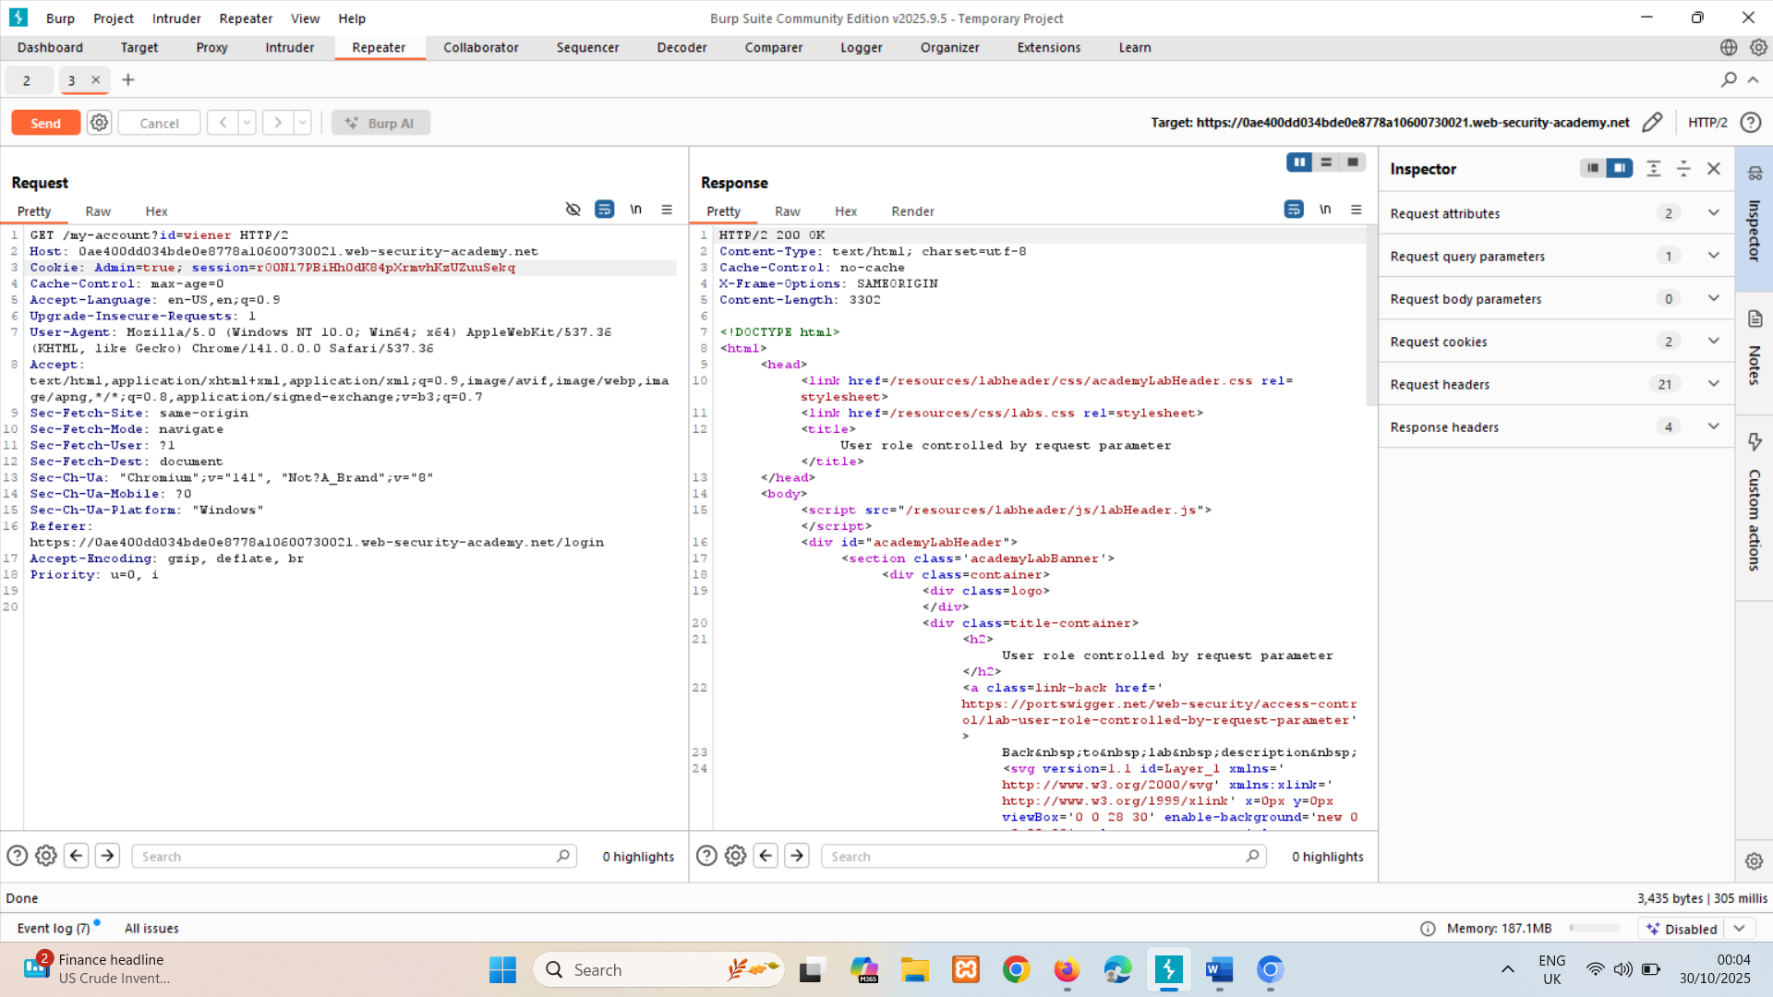

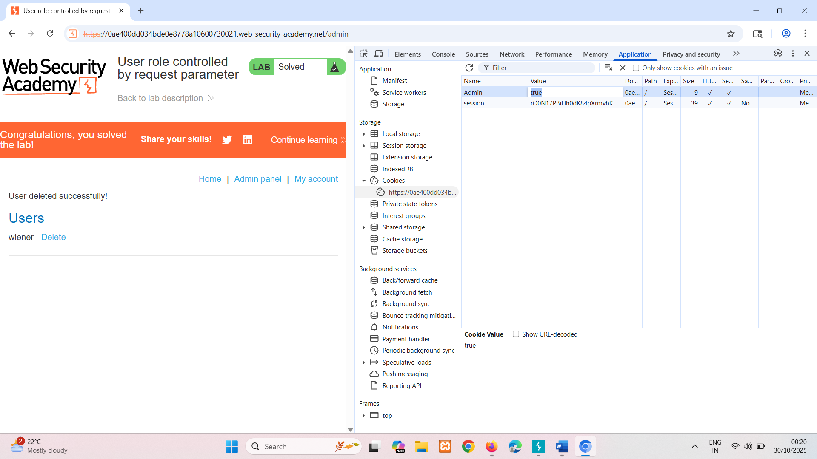  
or can do using post method

LAB

APPRENTICE [User role can be modified in user profile](https://portswigger.net/web-security/access-control/lab-user-role-can-be-modified-in-user-profile)   
Sol-  
here change email field is vulnerable, after changing email it showing json response, where roleid:1 so to change change it is to 2 by modifying json

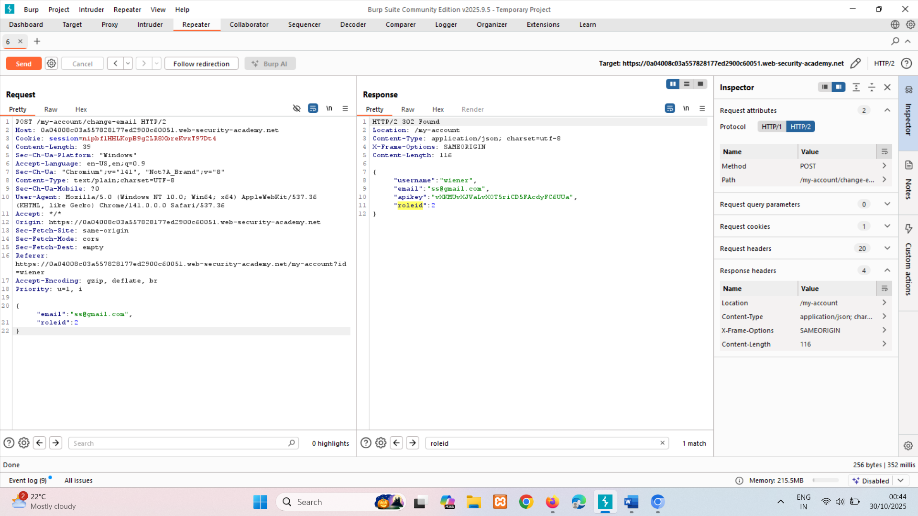

### Broken access control resulting from platform misconfiguration

Some applications enforce access controls at the platform layer. they do this by restricting access to specific URLs and HTTP methods based on the user's role. For example, an application might configure a rule as follows:

DENY: POST, /admin/deleteUser, managers

This rule denies access to the POST method on the URL /admin/deleteUser, for users in the managers group. Various things can go wrong in this situation, leading to access control bypasses.

Some application frameworks support various non-standard HTTP headers that can be used to override the URL in the original request, such as X-Original-URL and X-Rewrite-URL. If a website uses rigorous front-end controls to restrict access based on the URL, but the application allows the URL to be overridden via a request header, then it might be possible to bypass the access controls using a request like the following:

POST / HTTP/1.1   
X-Original-URL: /admin/deleteUser   
...

LAB

PRACTITIONER [URL-based access control can be circumvented](https://portswigger.net/web-security/access-control/lab-url-based-access-control-can-be-circumvented)   
Sol- use non-standard HTTP header 🡪X-Original-URL: /admin   
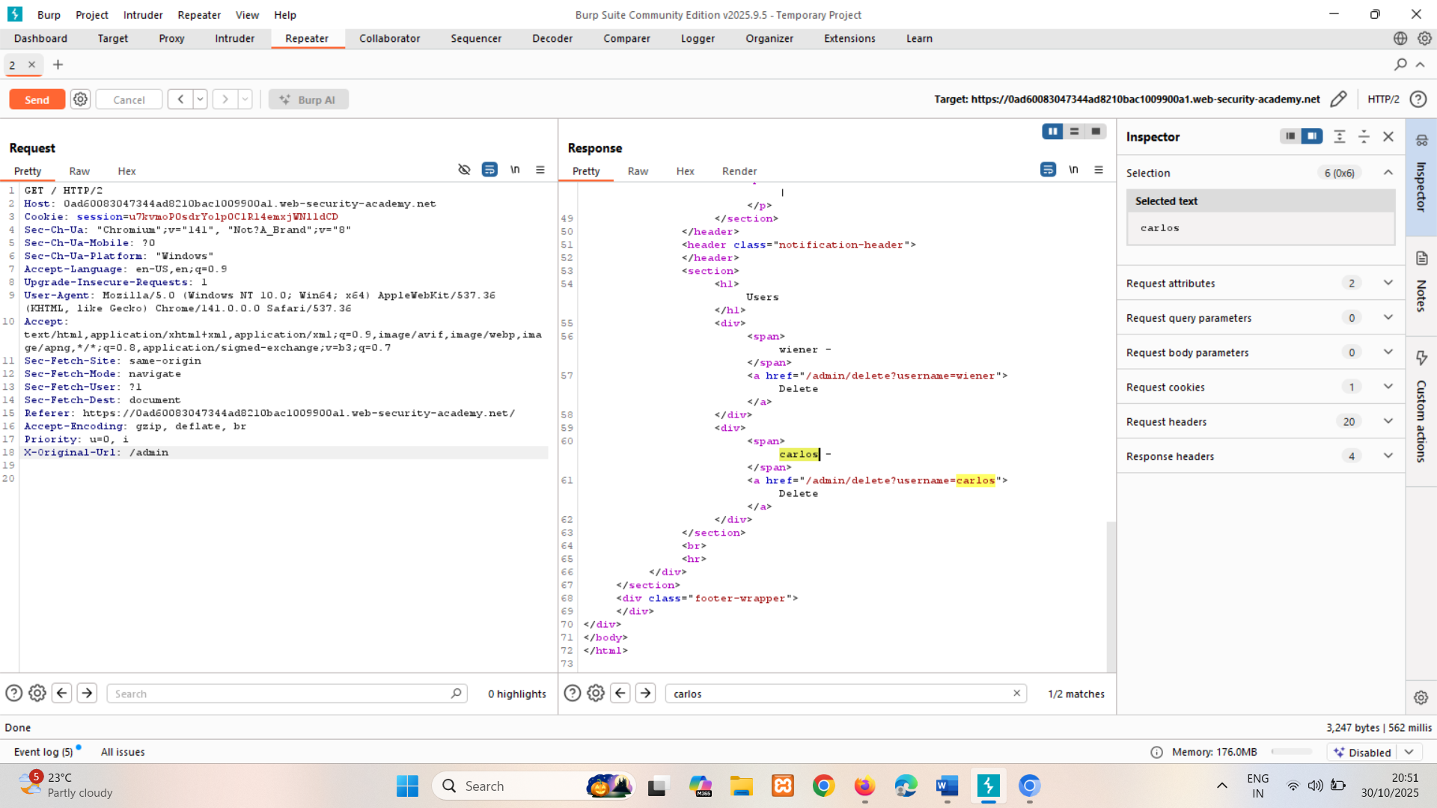

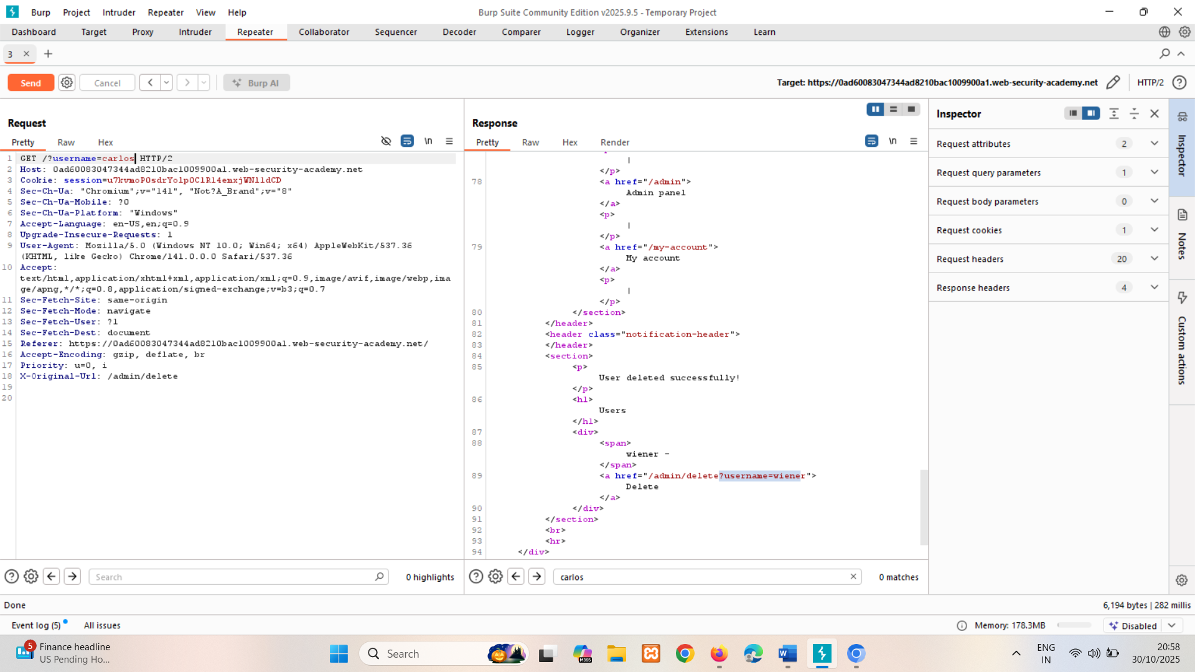

By using POST method should have done, but its working with GET method too.

--------------------------------------------------------------------------------------------------------------------------------------

An alternative attack relates to the HTTP method used in the request. The front-end controls described in the previous sections restrict access based on the URL and HTTP method. Some websites tolerate different HTTP request methods when performing an action. If an attacker can use the GET (or another) method to perform actions on a restricted URL, they can bypass the access control that is implemented at the platform layer.

LAB

PRACTITIONER [Method-based access control can be circumvented](https://portswigger.net/web-security/access-control/lab-method-based-access-control-can-be-circumvented)   
Sol- copying user's(wiener) session cookie to admin request and change request method(it will change to GET) in burp.

Functionality of admin

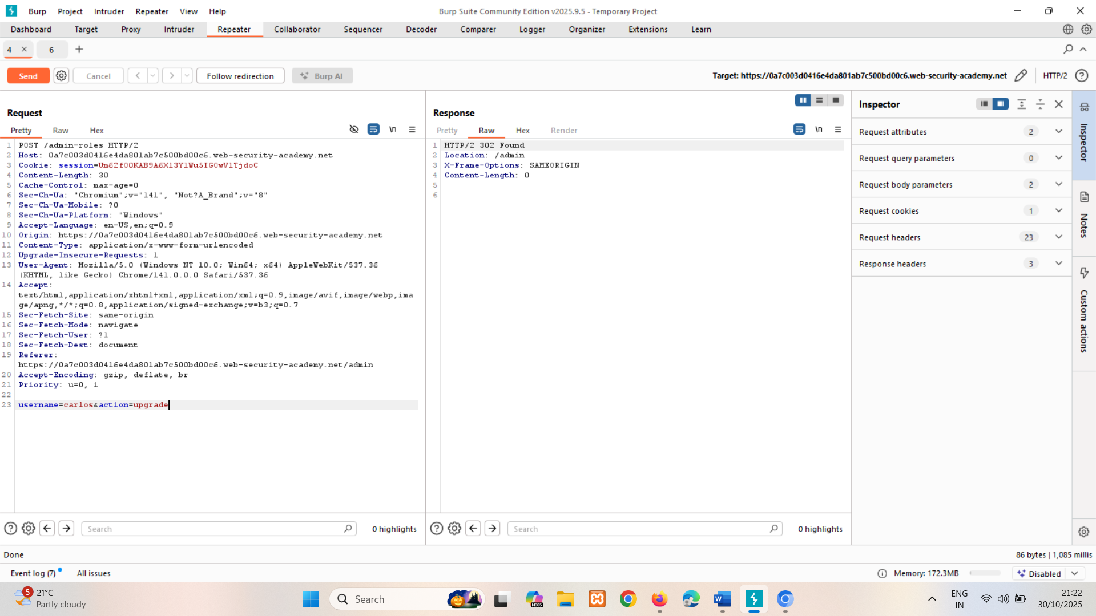

Copy session and paste it in admin tab and change its method

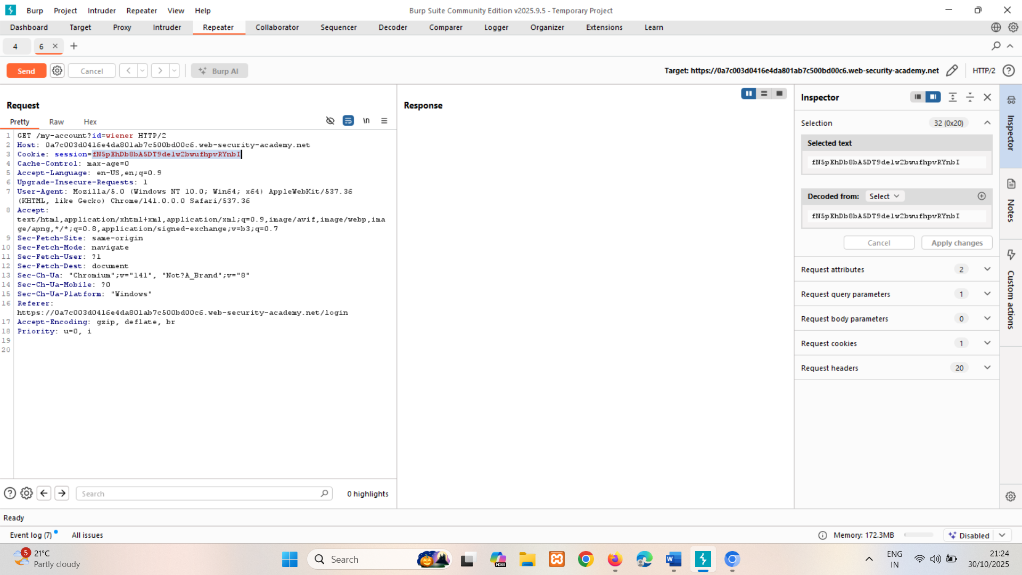

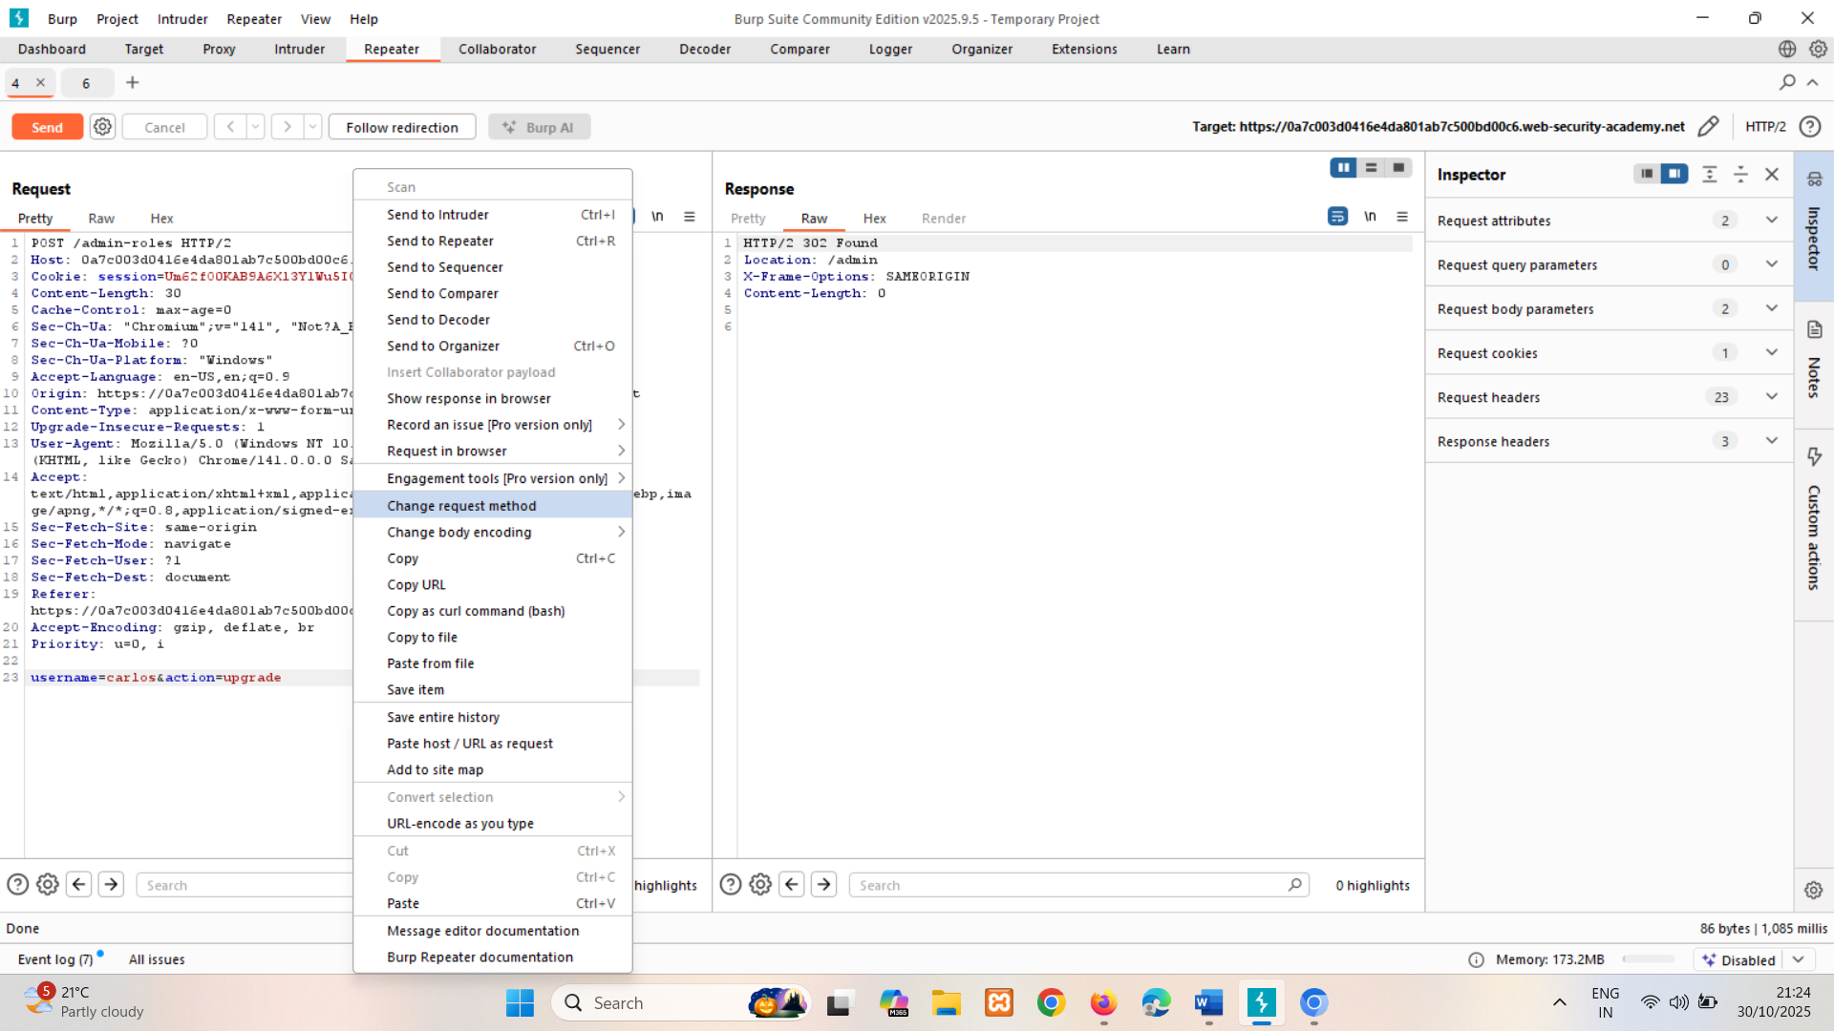

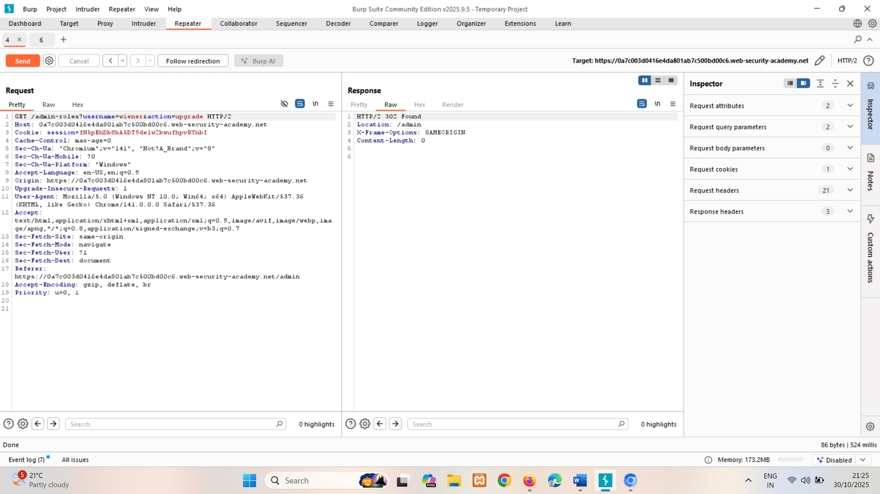

Follow redirection in burp repeater it says ok.

Horizontal privilege escalation

Horizontal privilege escalation occurs if a user is able to gain access to resources belonging to another user, instead of their own resources of that type. For example, if an employee can access the records of other employees as well as their own, then this is horizontal privilege escalation.

Horizontal privilege escalation attacks may use similar types of exploit methods to vertical privilege escalation. For example, a user might access their own account page using the following URL:

https://insecure-website.com/myaccount?id=123

If an attacker modifies the id parameter value to that of another user, they might gain access to another user's account page, and the associated data and functions.

**Note**

This is an example of an insecure direct object reference (IDOR) vulnerability. This type of vulnerability arises where user-controller parameter values are used to access resources or functions directly.

LAB

APPRENTICE [User ID controlled by request parameter](https://portswigger.net/web-security/access-control/lab-user-id-controlled-by-request-parameter)   
Sol- change id params to carlos  
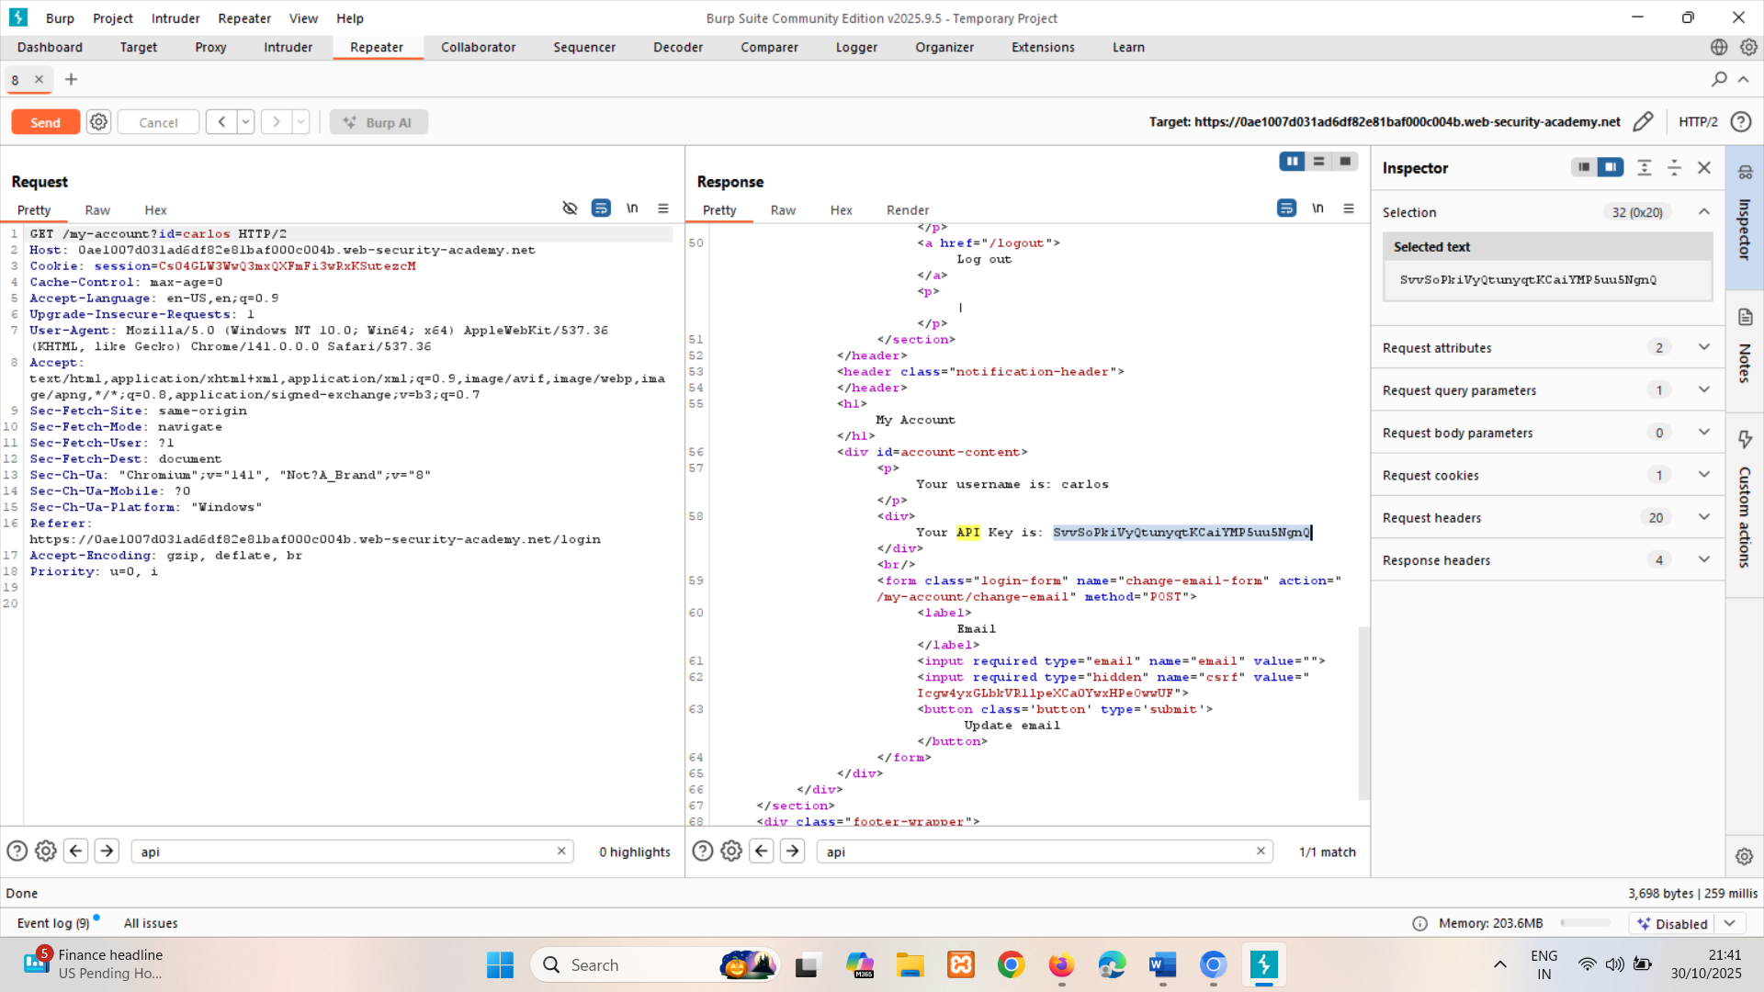

In some applications, the exploitable parameter does not have a predictable value. For example, instead of an incrementing number, an application might use globally unique identifiers (GUIDs) to identify users. This may prevent an attacker from guessing or predicting another user's identifier. However, the GUIDs belonging to other users might be disclosed elsewhere in the application where users are referenced, such as user messages or reviews.

LAB

APPRENTICE [User ID controlled by request parameter, with unpredictable user IDs](https://portswigger.net/web-security/access-control/lab-user-id-controlled-by-request-parameter-with-unpredictable-user-ids)   
sol- Login and find post by carlos, capture it in burp userid visible. Now copy it and paste in wieners request.

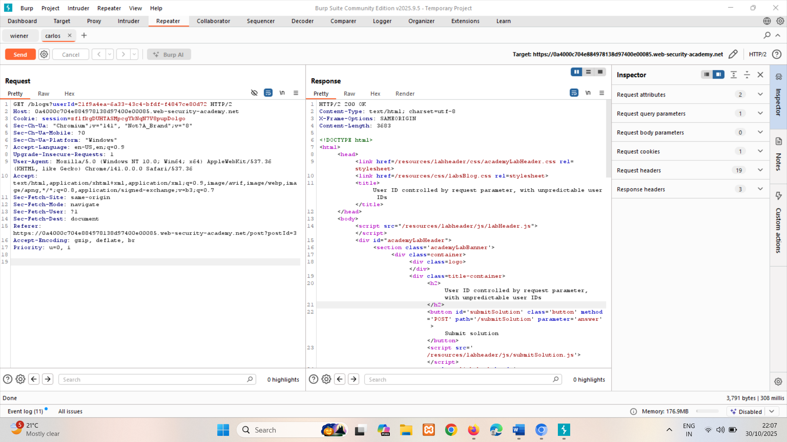

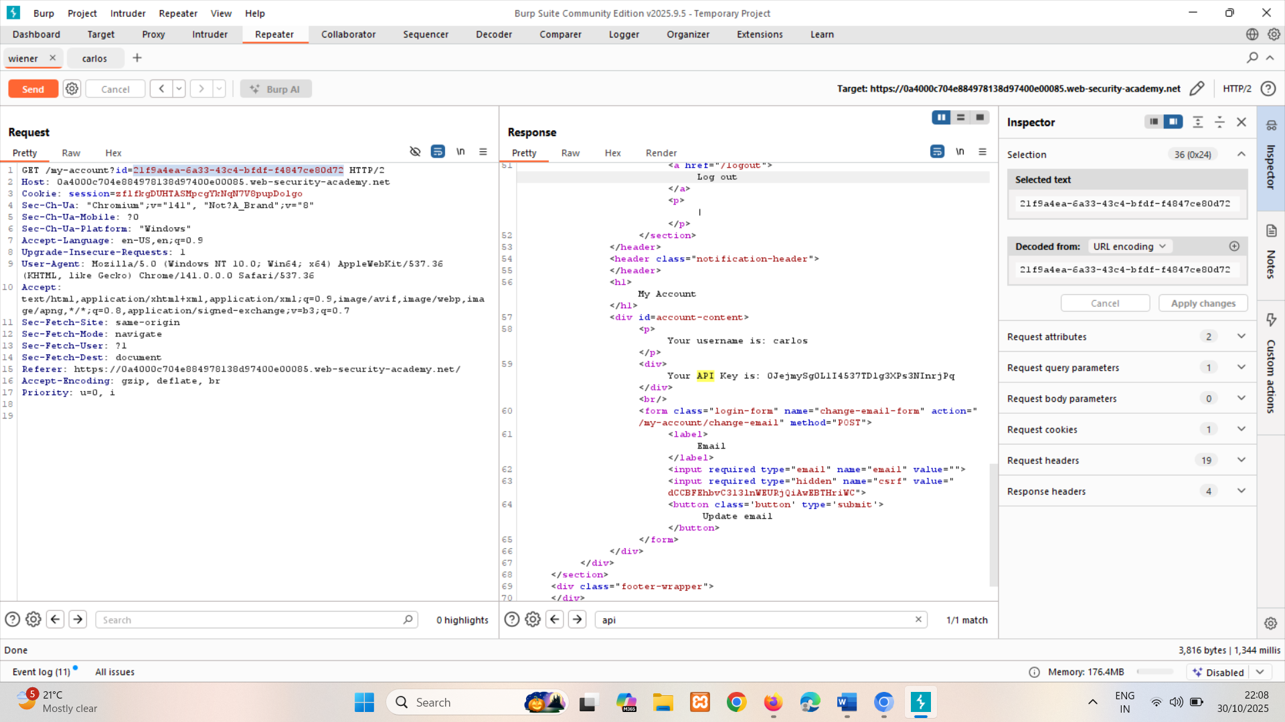

In some cases, an application does detect when the user is not permitted to access the resource, and returns a redirect to the login page. However, the response containing the redirect might still include some sensitive data belonging to the targeted user, so the attack is still successful.

LAB

APPRENTICE [User ID controlled by request parameter with data leakage in redirect](https://portswigger.net/web-security/access-control/lab-user-id-controlled-by-request-parameter-with-data-leakage-in-redirect)   
Sol- id=carlos Here if change id it redirects to the login page but still gives response 302 Found and it contains API key.

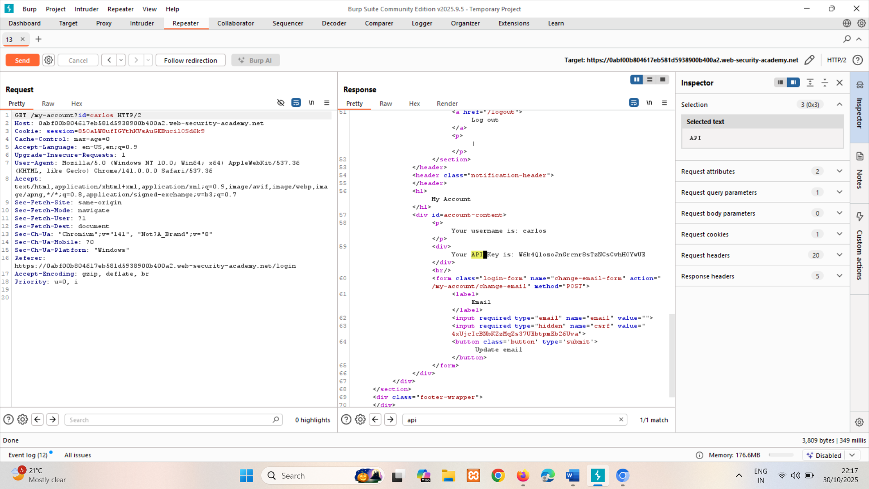

### Horizontal to vertical privilege escalation

Often, a horizontal privilege escalation attack can be turned into a vertical privilege escalation, by compromising a more privileged user. For example, a horizontal escalation might allow an attacker to reset or capture the password belonging to another user. If the attacker targets an administrative user and compromises their account, then they can gain administrative access and so perform vertical privilege escalation.

An attacker might be able to gain access to another user's account page using the parameter tampering technique already described for horizontal privilege escalation:

https://insecure-website.com/myaccount?id=456

If the target user is an application administrator, then the attacker will gain access to an administrative account page. This page might disclose the administrator's password or provide a means of changing it, or might provide direct access to privileged functionality.

LAB

APPRENTICE [User ID controlled by request parameter with password disclosure](https://portswigger.net/web-security/access-control/lab-user-id-controlled-by-request-parameter-with-password-disclosure)   
Sol- id=administrator

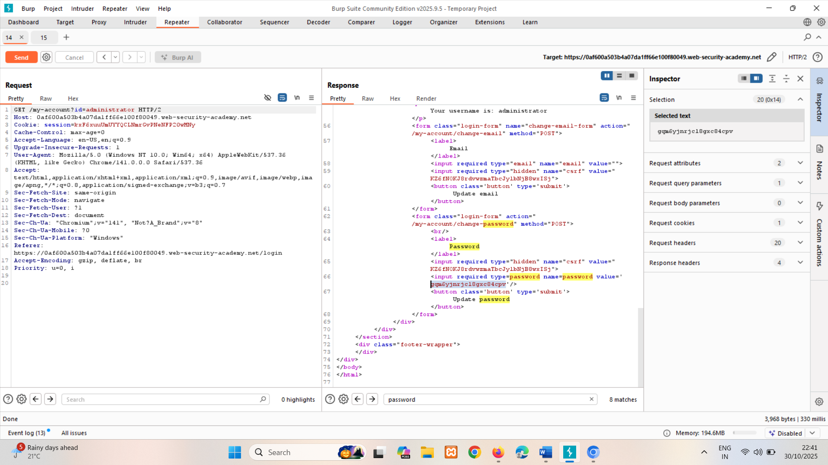

Insecure direct object references (IDOR)

In this section, we will explain what insecure direct object references (IDOR) are and describe some common vulnerabilities.

What are insecure direct object references (IDOR)?

Insecure direct object references (IDORs) are a subcategory of access control vulnerabilities. IDORs occur if an application uses user-supplied input to access objects directly and an attacker can modify the input to obtain unauthorized access. It was popularized by its appearance in the OWASP 2007 Top Ten. It's just one example of many implementation mistakes that can provide a means to bypass access controls.

### IDOR examples

There are many examples of access control vulnerabilities where user-controlled parameter values are used to access resources or functions directly.

#### IDOR vulnerability with direct reference to database objects

Consider a website that uses the following URL to access the customer account page, by retrieving information from the back-end database:

https://insecure-website.com/customer_account?customer_number=132355

Here, the customer number is used directly as a record index in queries that are performed on the back-end database. If no other controls are in place, an attacker can simply modify the customer_number value, bypassing access controls to view the records of other customers. This is an example of an IDOR vulnerability leading to horizontal privilege escalation.

An attacker might be able to perform horizontal and vertical privilege escalation by altering the user to one with additional privileges while bypassing access controls. Other possibilities include exploiting password leakage or modifying parameters once the attacker has landed in the user's accounts page, for example.

#### IDOR vulnerability with direct reference to static files

IDOR vulnerabilities often arise when sensitive resources are located in static files on the server-side filesystem. For example, a website might save chat message transcripts to disk using an incrementing filename, and allow users to retrieve these by visiting a URL like the following:

https://insecure-website.com/static/12144.txt

In this situation, an attacker can simply modify the filename to retrieve a transcript created by another user and potentially obtain user credentials and other sensitive data.

LAB

APPRENTICE [Insecure direct object references](https://portswigger.net/web-security/access-control/lab-insecure-direct-object-references)   
Sol- change to 1.txt

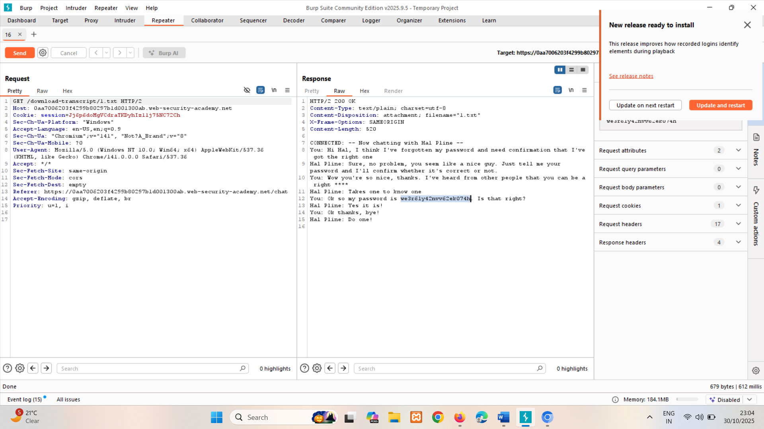

### Access control vulnerabilities in multi-step processes

Many websites implement important functions over a series of steps. This is common when:

* A variety of inputs or options need to be captured.
* The user needs to review and confirm details before the action is performed.

For example, the administrative function to update user details might involve the following steps:

1. Load the form that contains details for a specific user.
2. Submit the changes.
3. Review the changes and confirm.

Sometimes, a website will implement rigorous access controls over some of these steps, but ignore others. Imagine a website where access controls are correctly applied to the first and second steps, but not to the third step. The website assumes that a user will only reach step 3 if they have already completed the first steps, which are properly controlled. An attacker can gain unauthorized access to the function by skipping the first two steps and directly submitting the request for the third step with the required parameters.

LAB

PRACTITIONER [Multi-step process with no access control on one step](https://portswigger.net/web-security/access-control/lab-multi-step-process-with-no-access-control-on-one-step)   
Sol- copy wieners session and add it in admin (also change params)

Copy session  
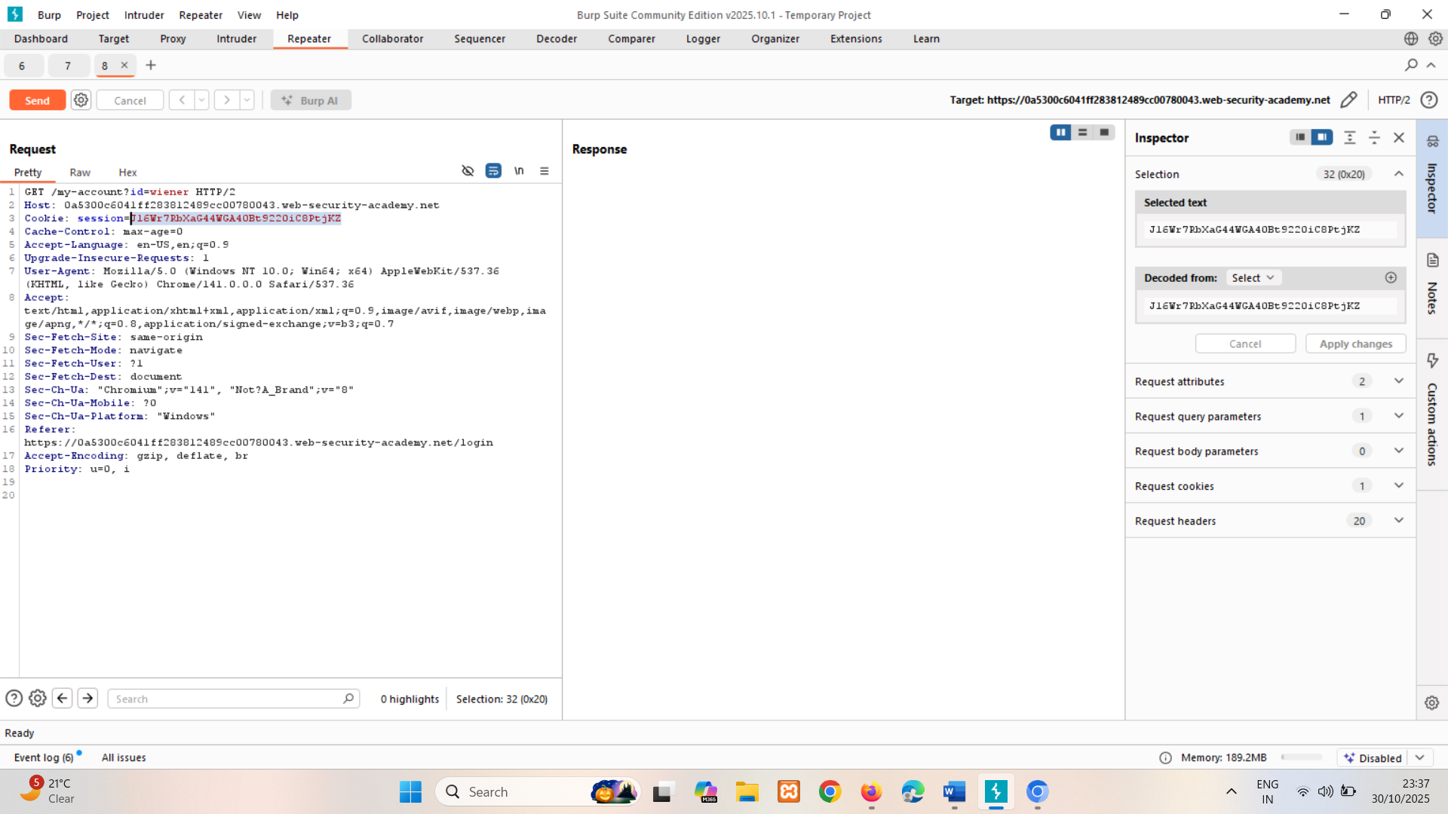

Paste in admins session

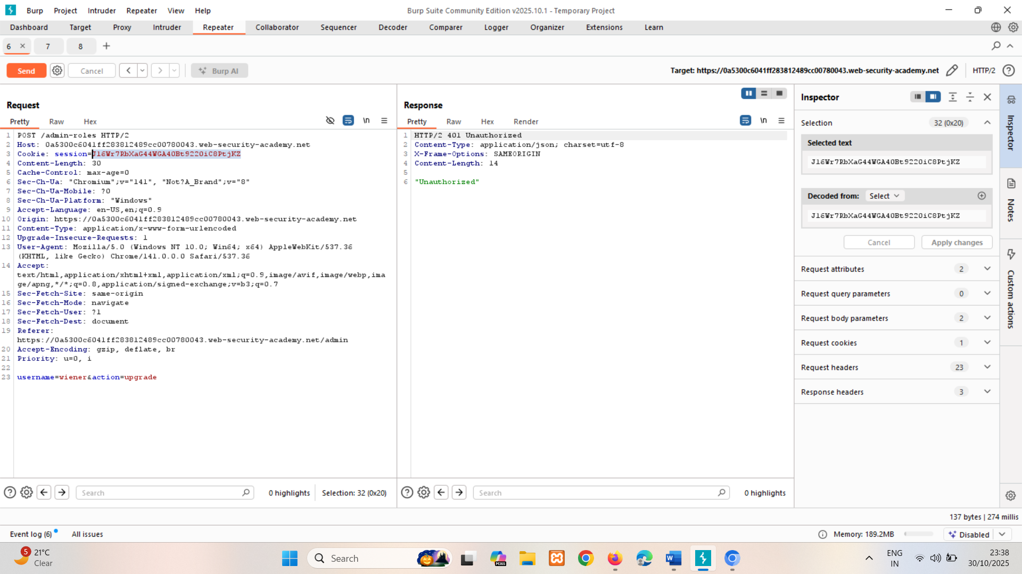

And for MFA too  
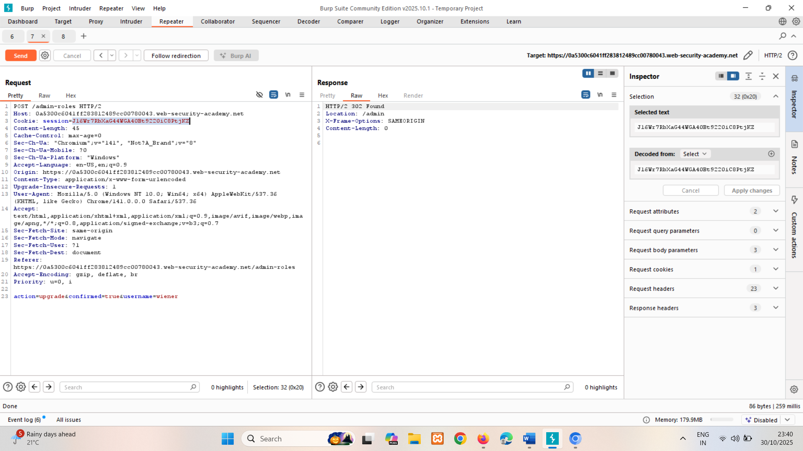

We get 302 satus code so we have promoted wiener.

### Referer-based access control

Some websites base access controls on the Referer header submitted in the HTTP request. The Referer header can be added to requests by browsers to indicate which page initiated a request.

For example, an application robustly enforces access control over the main administrative page at /admin, but for sub-pages such as /admin/deleteUser only inspects the Referer header. If the Referer header contains the main /admin URL, then the request is allowed.

In this case, the Referer header can be fully controlled by an attacker. This means that they can forge direct requests to sensitive sub-pages by supplying the required Referer header, and gain unauthorized access.

LAB

PRACTITIONER [Referer-based access control](https://portswigger.net/web-security/access-control/lab-referer-based-access-control)   
Sol- copy wiener’s session and paste in admin

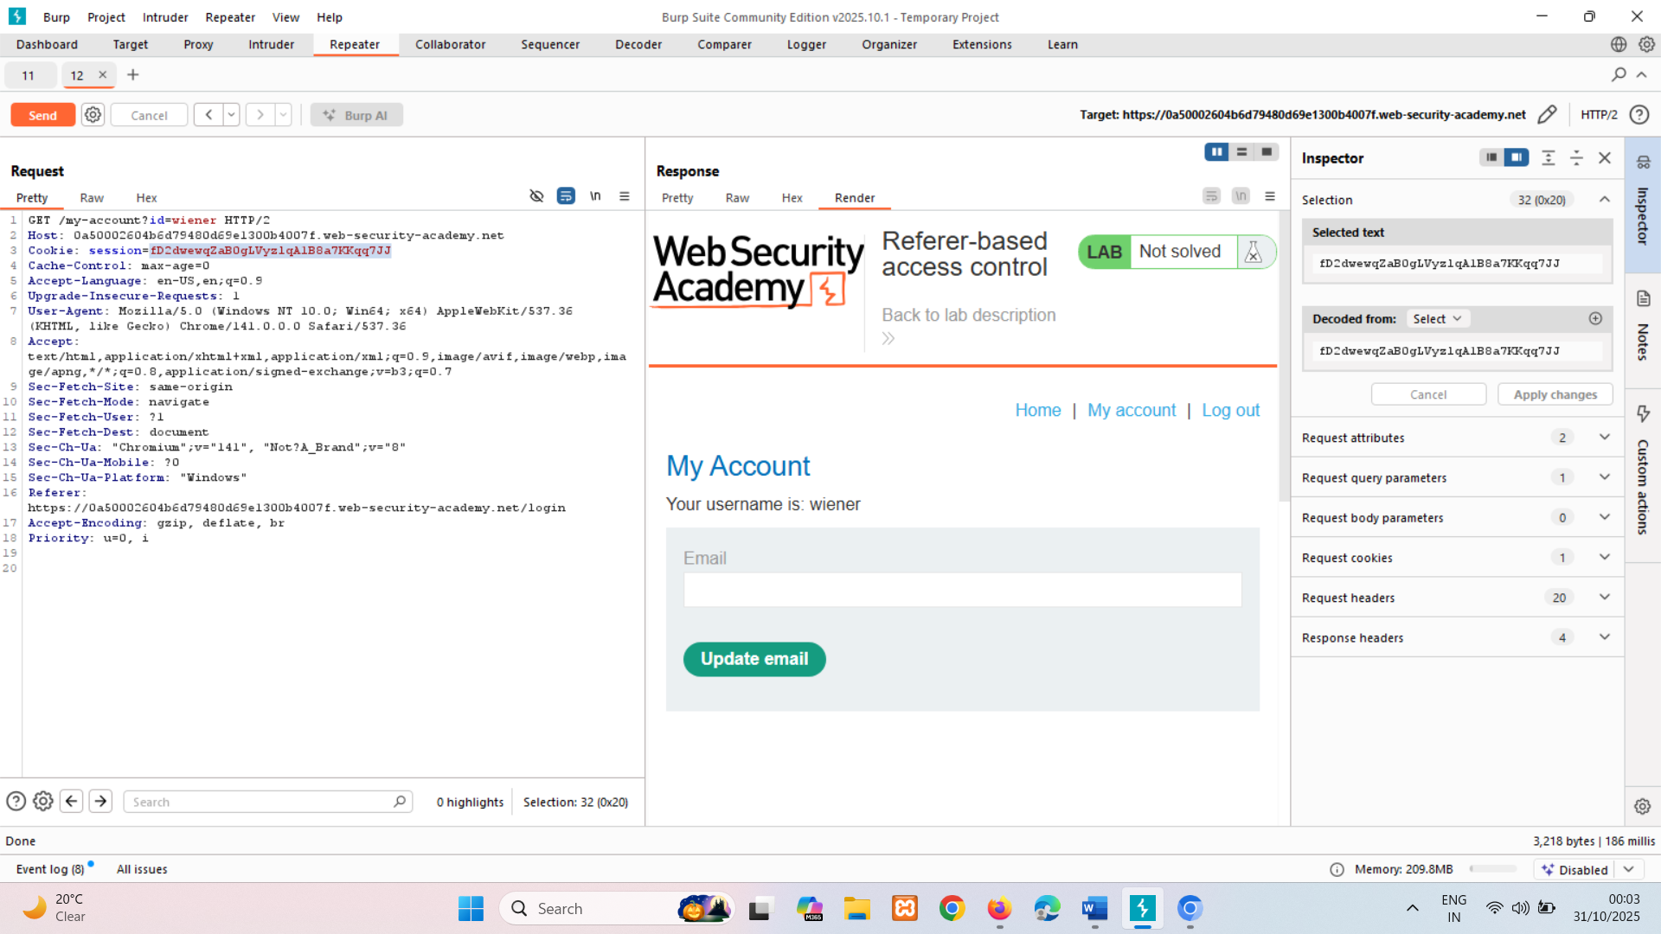

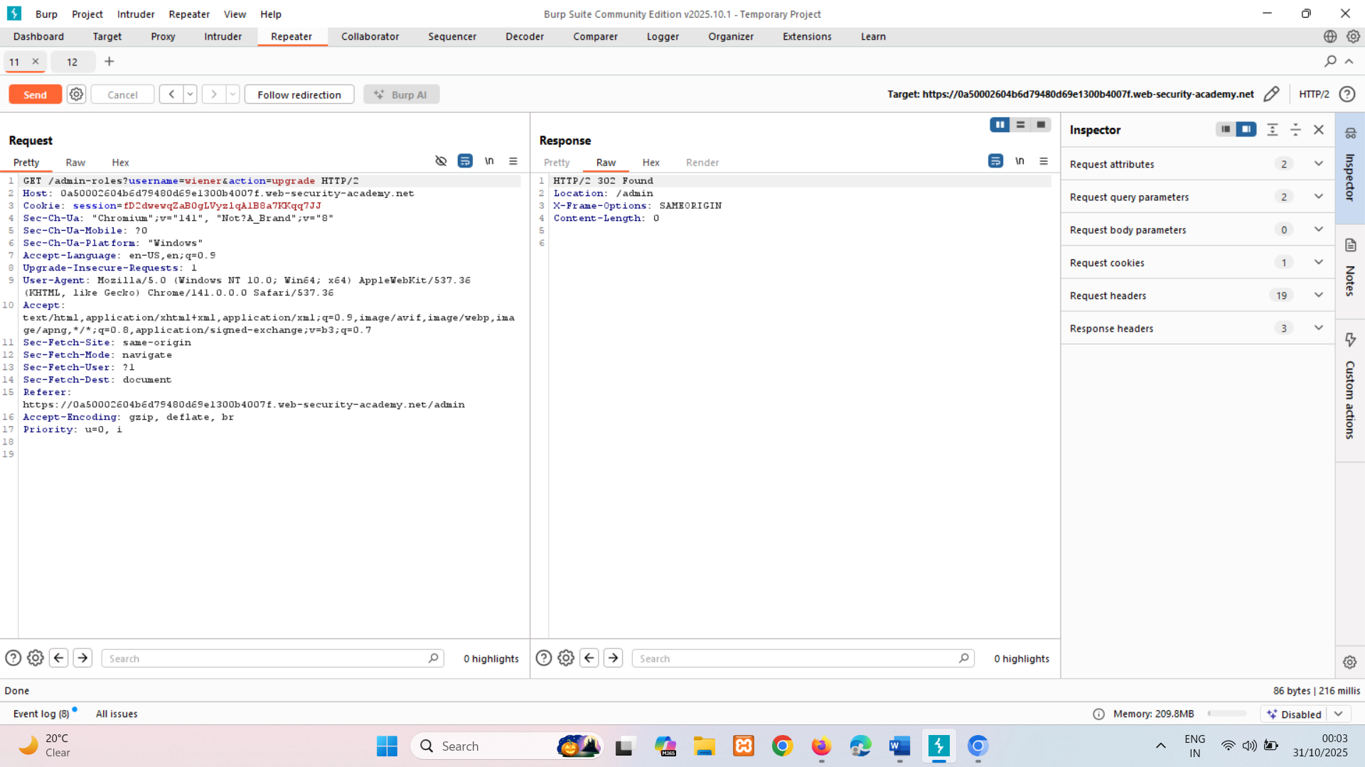

302 status code, means access to wiener is successful.

It using Referer: <https://0a50002604b6d79480d69e1300b4007f.web-security-academy.net/admin> its completely wrong ,cause we can manipulated it so if its not there request shows 401 Unauthorized.

### Location-based access control

Some websites enforce access controls based on the user's geographical location. This can apply, for example, to banking applications or media services where state legislation or business restrictions apply. These access controls can often be circumvented by the use of web proxies, VPNs, or manipulation of client-side geolocation mechanisms.

# How to prevent access control vulnerabilities

Access control vulnerabilities can be prevented by taking a defense-in-depth approach and applying the following principles:

* Never rely on obfuscation alone for access control.
* Unless a resource is intended to be publicly accessible, deny access by default.
* Wherever possible, use a single application-wide mechanism for enforcing access controls.
* At the code level, make it mandatory for developers to declare the access that is allowed for each resource, and deny access by default.
* Thoroughly audit and test access controls to ensure they work as designed.